a


PROJECT BASED LEARNING (PBL-4) LAB (CSP390)
CheckMe — Smart Mess Ecosystem
B.TECH 3rd YEAR
SEMESTER: 6th
SESSION: 2025-2026
Submitted By:
Aashish Rajput (2023329421)

SECTION: I- G2

Submitted To
Dr. Amit Sharma
Associate Professor

DEPARTMENT OF COMPUTER SCIENCE & ENGINEERING
SHARDA SCHOOL OF ENGINEERING & TECHNOLOGY
SHARDA UNIVERSITY, GREATER NOIDA

Table of Contents Page No
Project Title 3
Team / Group Formation: 3
Technologies to be used 3
Tools 3
Problem Statement 3
Literature Survey 4
Project Description 4
Project Modules: Design/Algorithm 4
Implementation Methodology 4
Result & Conclusion 4
Future Scope and further enhancement of the Project 4
Advantages of this Project 4
Outcome 5
References 5

Project Title
A premium, full-stack mess management platform designed for modern college hostels to replace manual logs with a real-time, automated digital ecosystem.

Team / Group Formation:
<Guidelines: Team should not exceed 3 members >
Possible Roles are: Developer, Tester, and Designer
Font: Times New Roman; Font Size: 12, Color Black
S. No | Student Name | Roll Number | System ID | Role
1 | Aashish Rajput | 2301010007 | 2023329421 | Full-stack  Developer
2
3

Technologies to be used
Software Platform
- Front-end: Next.js 16.1.6 (App Router), React 19.2.4, TypeScript.
- Styling: Tailwind CSS v4.1.9, Framer Motion (for animations), Lucide React (Icons).
- UI Components: Radix UI Primitives, shadcn/ui.
- Backend/Database: Google Firebase (Firestore, Authentication, Cloud Storage).
- Data Processing: Tesseract.js (OCR), xlsx (Excel Parsing), pdf-parse-new (PDF Extraction).
Hardware Platform
Processor: Intel Core i3 / AMD Ryzen 5 or higher.
RAM: 8GB Minimum (16GB Recommended for development).
Storage: 256GB SSD.
Operating System: Windows 10/11, Linux, or macOS.
Tools: VS Code (Editor), Chrome/Edge/Firefox (Browser), Firebase Console.

Tools
VS Code: Primary IDE for coding and debugging.
Firebase Console: For managing Firestore database, user authentication, and security rules.
Git/GitHub: For version control and collaborative development.
Vercel Analytics: For monitoring application performance and user engagement.

Problem Statement
Background: Traditional college mess systems rely on handwritten registers for attendance and printed sheets for menus. This leads to several issues:
1. Lack of Transparency: Students cannot track their attendance or provide real-time feedback.
2. Inefficient Management: Manually updating menus for emergency changes is slow and prone to errors.
3. Food Waste: Without data on attendance trends, mess staff struggle to predict food requirements.
4. Solution: CheckMe digitizes these processes, providing a centralized dashboard where students see live menus, wardens mark attendance instantly, and mess staff manage inventory with AI-driven menu parsing.
Literature Survey
The rapid digitization of campus infrastructure has led to the development of several hostel and mess management systems aimed at improving operational efficiency, food quality monitoring, attendance tracking, and waste reduction. Recent studies emphasize automation of food ordering, billing, and attendance systems to replace traditional manual registers. Bhattarai et al. proposed a QR-based canteen management system that automates food ordering and payment processes, thereby reducing queue time and improving transaction transparency [1]. Similarly, a Hostel Mess Food Management System introduced a web-based platform for handling daily meal scheduling, inventory tracking, and billing operations [2]. A comprehensive web-based Mess Management System further demonstrated how centralized databases enhance accuracy in financial and attendance records [3]. MealMap (2025) focused on aligning food preparation with student consumption patterns to minimize food wastage in hostels [4]. RFID-based Smart Canteen systems have been implemented to automate student identification and transaction logging, thereby ensuring accurate attendance and billing [5]. Advanced smart canteen automation platforms integrate real time monitoring and analytics dashboards for administrative decision-making [6]. Food waste detection has also gained attention in recent research. A computer vision-based approach using YOLOv11 was developed to detect leftover food on plates, enabling automated waste measurement in institutional cafeterias [7]. Studies on mitigating cooked food wastage in hostel messes highlight behavioral and operational factors influencing waste generation [8]. RFID-based attendance systems further contribute to precise meal count tracking, reducing over preparation of food [9]. 7 Security and monitoring systems are equally significant in hostel environments. Android-based hostel security systems incorporating facial recognition improve real-time monitoring and student safety [10]. Automated Hostel Management Systems utilizing RFID technologies enable controlled entry-exit tracking and visitor management [11]. Food waste awareness platforms such as FoodWise apply data analytics and gamification techniques to influence user behavior toward sustainable consumption [12]. Additionally, computer vision models in food recognition research provide a foundation for smart menu planning and portion control systems [13]. Smart canteen ordering systems also emphasize reducing waiting time and improving operational efficiency through mobile-based interfaces [14]. Online hostel and mess finder platforms enhance accessibility and information transparency for students seeking accommodation and dining facilities [15]. Although existing systems address specific operational aspects such as ordering, attendance, or waste detection, most solutions function independently without integrating analytics, personalization, and real-time monitoring into a unified platform. Therefore, the proposed CheckMe – Real-Time Hostel and Mess Management System aims to combine attendance tracking, food ordering, feedback analysis, and waste monitoring into a single scalable digital ecosystem.
Existing Solutions: Manual registers (paper-based), static PDF menus (non-interactive).
Our Findings: Students prefer mobile-first, dark-themed interfaces with real-time updates. The integration of OCR (Optical Character Recognition) is rare in campus apps, making CheckMe a unique solution for converting paper menus to digital formats instantly.
CheckMe digitizes these processes, providing a centralized dashboard where students see live menus, wardens mark attendance instantly, and mess staff manage inventory with AI-driven menu parsing.

Project Description
Scope of Work:
1. Digitlizing Attendance: Real-time marking system with history logs.
2. Role-Based Access: Secure portals for Students, Wardens, and Mess Representatives.
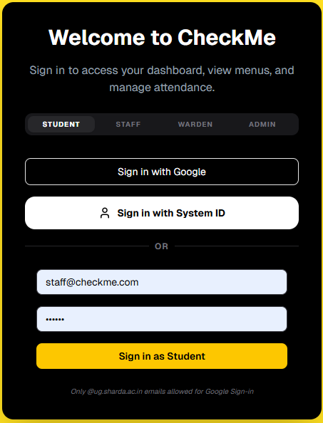
3. Interactive Analytics: Interactive AnalVisualizing student feedback on food quality.ytics

Project Modules: Design/Algorithm
- Student Hub module:
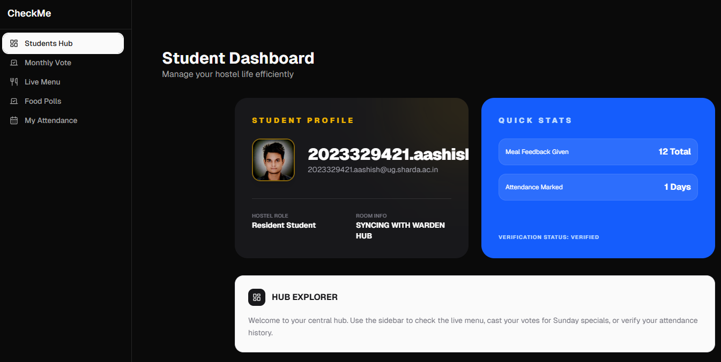
Live Menu: Highlighting the current meal based on time.
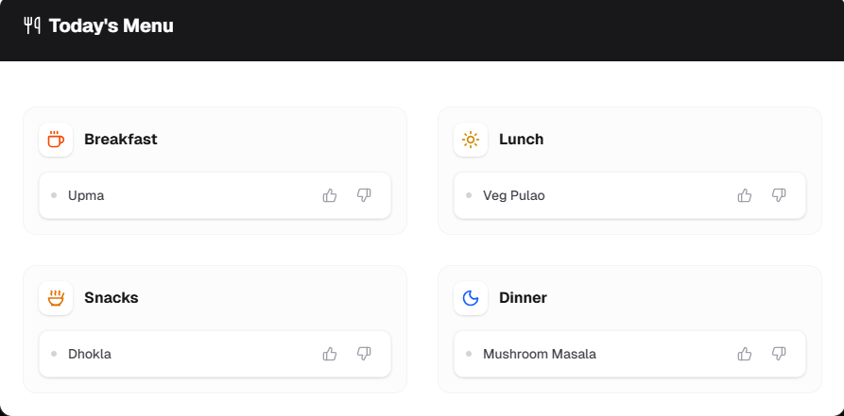
Voting System: Democratic special-meal polls and surveys.
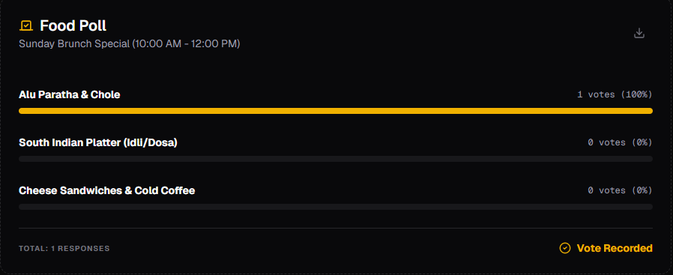

- Warden Control Module
Broadcast Engine: Global notification system.(upcoming)
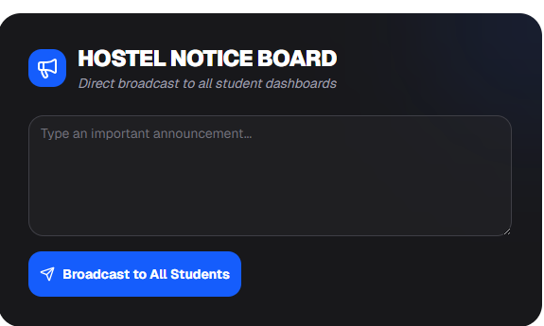
Feedback Analytics: Charts visualizing mess performance metrics.
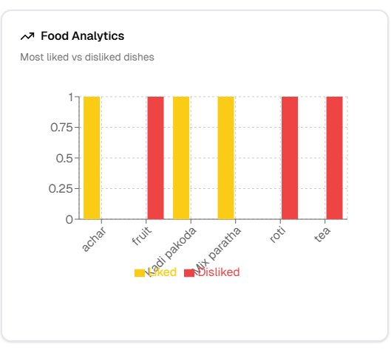
Attendence module:
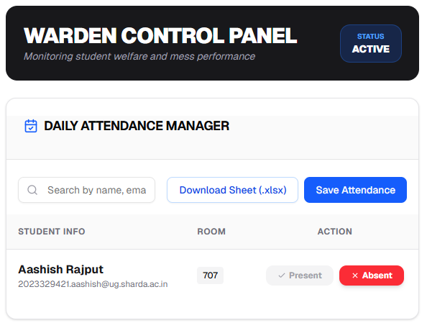
3. Mess Administration Module
Inventory Manager: Tracking supply levels (Rice, Milk, Chicken, etc.).
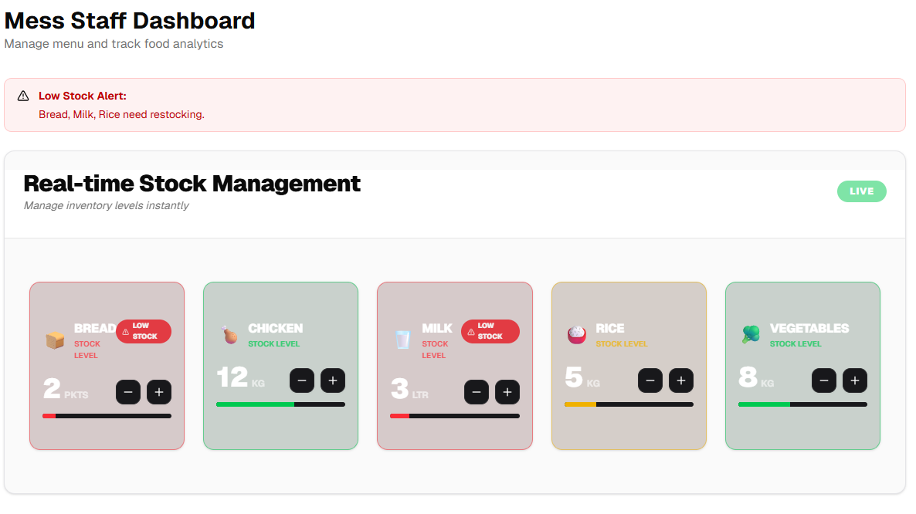

Implementation Methodology
The project follows an Agile/Scrum methodology.
Data Model: Firestore NoSQL database with collections for `attendance`, `inventory`, `polls`, `surveys`, and `messMenu`.
Logic Flow: React Context (`AuthContext.tsx`) manages the global user state. Data is fetched via server-side props and updated via Next.js API routes with middleware security.
Testing: (Unit testing ) manual browser testing for responsive UI layouts.

Result & Conclusion
Achievements:
Successfully implemented a real-time, premium dark-themed UI using Tailwind CSS v4.
Conclusion: The project "CheckMe" has been successfully designed and developed to address
the critical operational inefficiencies in private hostels and PGs. By transitioning from manual, paper-based records to a centralized digital ecosystem, the system effectively bridges the communication gap between the three key stakeholders: Students, Wardens, and Mess Staff. The application successfully demonstrates that real-time technology can replace traditional notice boards and unstructured WhatsApp groups, creating a transparent and efficient living environment .

Future Scope and further enhancement of the Project
Payment Integration: Adding a gateway for paying mess bills digitally.
Consumption Prediction: Using AI to predict food quantities based on historical attendance.
PWA: Turning the web app into a Progressive Web App for offline access and push notifications.

Advantages of this Project
Transparency: Students see exactly what they are being charged for.
Efficiency: Reduces menu update time from hours to seconds using AI parsing.
Data-Driven: Helps authorities make better decisions based on actual student feedback.
Eco-Friendly: Eliminates the need for paper attendance logs and printed menus.

Outcome
Project to Product: The system is fully functional and ready for deployment in university hostels.

References
[1] https://www.researchgate.net/publication/382273584_QRbased_Canteen_Management_System
[2]https://www.researchgate.net/publication/400077759_HOSTEL_MESS_FOOD_MANAGEMEN
T_SYSTEM
[3]https://ijsrcseit.com/index.php/home/article/download/CSEIT241061126/CSEIT241061126/1030
[4] https://ijarcce.com/wp-content/uploads/2025/06/IJARCCE.2025.14634.pdf
[5] https://ijream.org/papers/IJREAMV06I0161145.pdf
[6] https://www.researchsquare.com/article/rs-8268462/latest.pdf
[7] https://www.mdpi.com/2076-3417/15/13/7137
[8] https://www.scribd.com/document/892017236/Mitigating-Wastage-of-Cooked-Food-inHostel-Mess-4
[9] https://www.researchgate.net/publication/348253883_RFID_Based_Attendance_System
[10] https://ijrar.org/papers/IJRAR2001661.pdf
[11] https://ijsret.com/wp-content/uploads/2025/01/IJSRET_V11_issue1_214.pdf
[12] https://arxiv.org/abs/2307.12882
[13] https://arxiv.org/abs/2405.11621
[14] https://www.irejournals.com/formatedpaper/1712570.pdf
[15] https://tijer.org/tijer/papers/TIJERC001278.pdf
[Next.js Documentation](https://nextjs.org/docs)
[Firebase Documentation](https://firebase.google.com/docs)
[React 19 Hooks API](https://react.dev)
[Tesseract.js GitHub Repository](https://github.com/naptha/tesseract.js)

Signature

Student Name | Student Sign | Faculty Name | Faculty Sign
Aashish Rajput |  | Dr. Amit Sharma

